**Deerwalk Institute Of Technology**

**Database Administration**

**Lab: 1**

**Submitted By: Submitted To:**

**Name: Sagar Giri Narayan Chalise**

**Roll No. 205**

**Date:**

**Installing Oracle Database 11g on Windows**

1. From Windows Explorer **setup.exe** from the \db\Disk1 directory is clicked and opened.
2. The product that we want to install is **Oracle Database 11g** so it is selected and clicked **Next**.

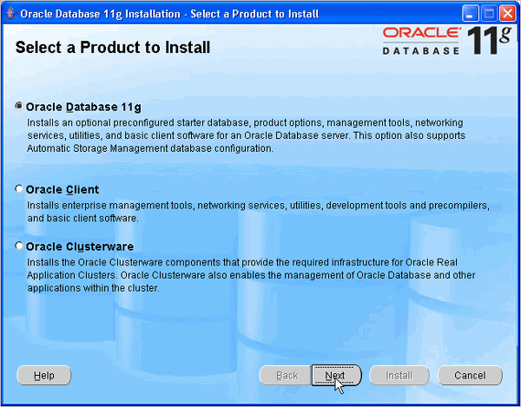

1. Perform a basic installation with a starter database. Enter **orcl** for the Global Database Name and **oracle** for Database Password and Confirm Password. Then, click **Next**.

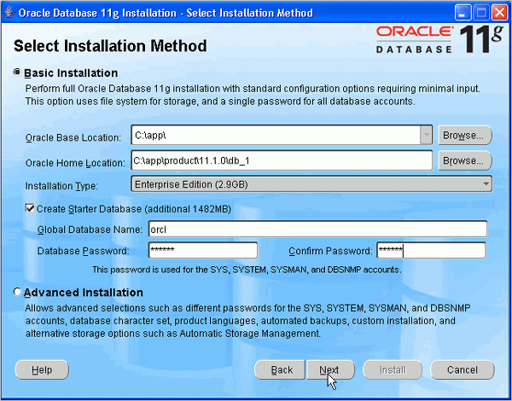

1. Oracle Configuration Manager allows us to associate our configuration information with our Metalink account. We can choose to enable it on this window. Then, click **Next.**

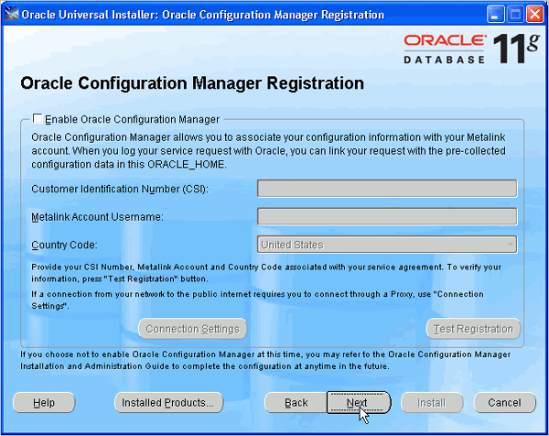

1. Review the Summary window to verify what is to be installed. Then, click **Install**.

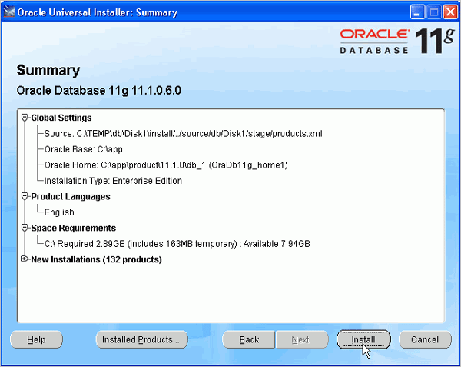

1. The progress window appears.

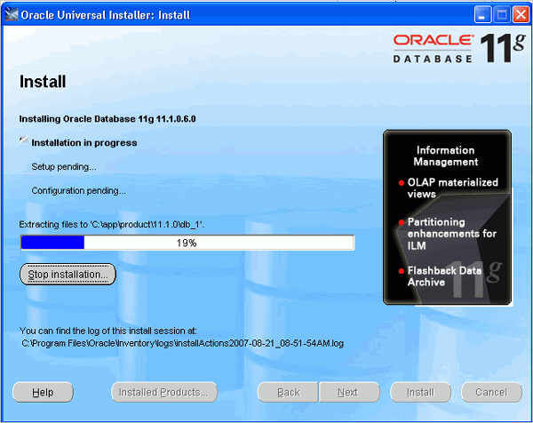

7) The Configuration Assistants window appears.

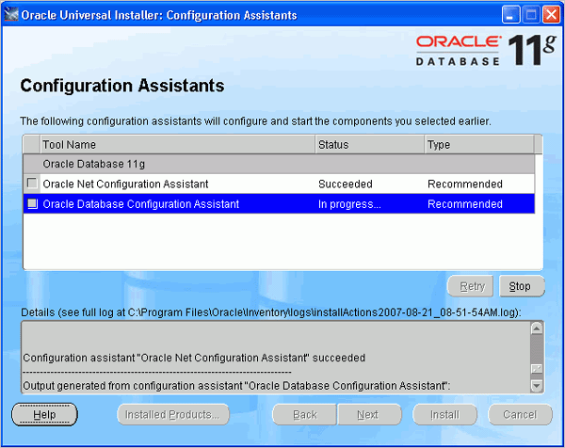

8) Our database is now being created.

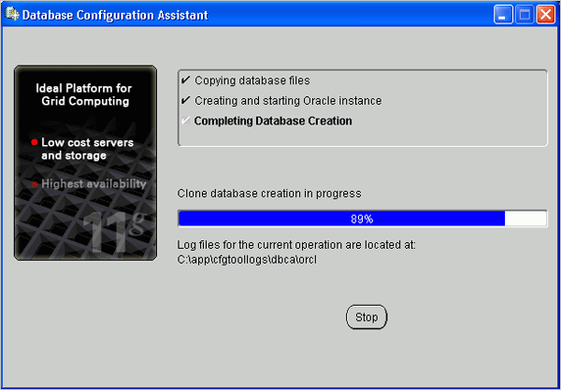

**9)** When the database has been created, we can unlock the users we want to use. Click **OK**.

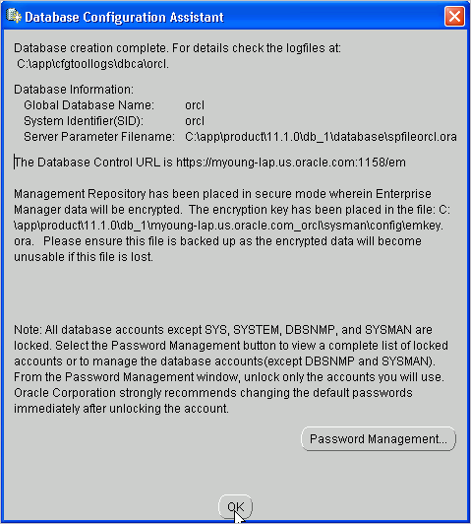

10) Click **Exit**. Click **Yes** to confirm exit.

